# User Manuel – For Application up to Part A

## Building and Starting Program

Navigate to the solution build title *Assignment 1.sln* right click on this file and navigate to the *Open With…* button and select *Microsoft Visual Studio.* Navigate to the navigation bar located at the top the Visual Studio window and select the *Build* drop down and select *Build* (alternatively enter Ctrl+Shift+B). Once successful, the bottom of the window will indicate this is successful, use the F5 button to launch the window. The program will start with the following window will appear:

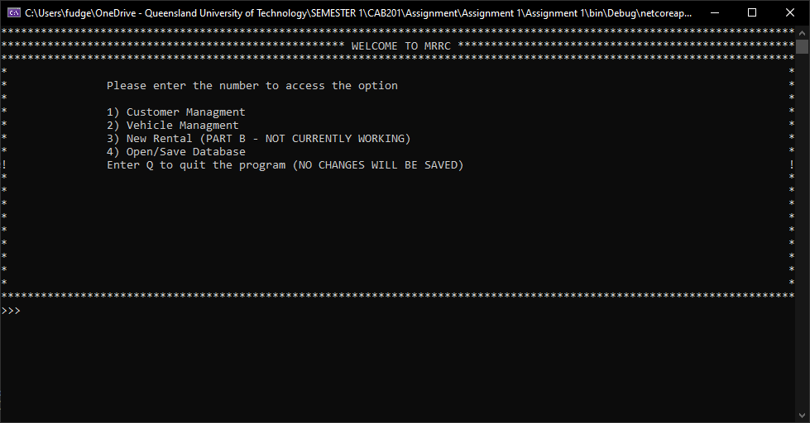

## Note About files:

By default, the rental, customer database and fleet database will be loaded from the Data folder in the provided zip folder. If an error occurred with loading. These files to the program these will display on the main screen. You can change which of these files are loaded in *4) Open/Save Database* (how to do this will be clarified later).

## Basic Navigation:

To Navigate to different parts simply enter the number associated with the option and hit the Enter Key. To go back to the previous screen type ‘B’ or ‘b’ and then hit enter, this will erase any changes and also prevent any new information being added. When ready to quit the program navigate to the main screen and enter ‘Q’ or ‘q’ again this will erase any unsaved changes, you can save changes in Open/Save Database.

## 

## Sub Screens

### Customer Management

Once in the customer Management screen the following will appear:

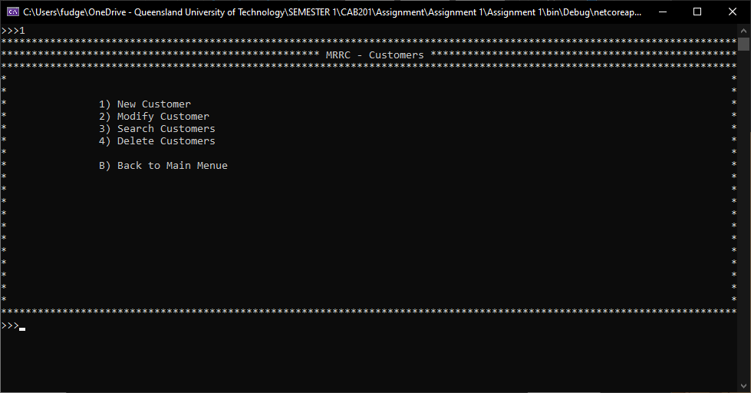

#### New Customer

When entering the new customer screen, the following will appear

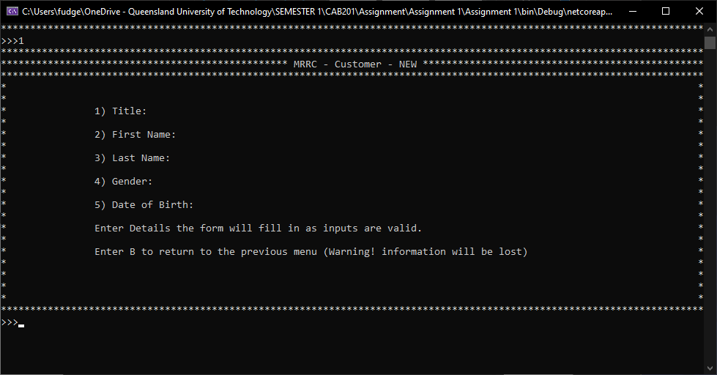

Simply type in each entry and hit enter. The form will fill in with each valid input. If an invalid input is entered an error describing what happened will appear.

Once all the fields are filled in A final prompt will appear (like below) if any information is incorrect enter N or n will be navigated to the modify screen to make any changes. If all is correct the customer will be added to the database.

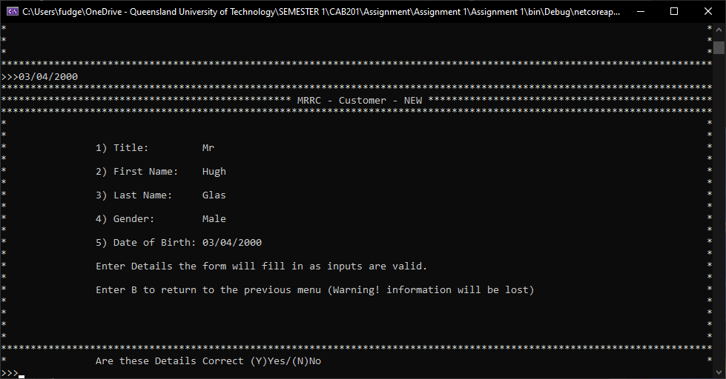

*NOTE:* Only the following titles are valid titles Mr, Mrs, Ms, Miss, Dr, Lord, Lady and Mx

If the customer already exists in the database, the following will appear:

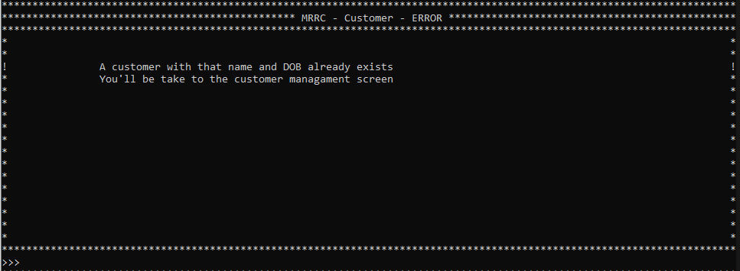

While if there were no issues the following will appear:

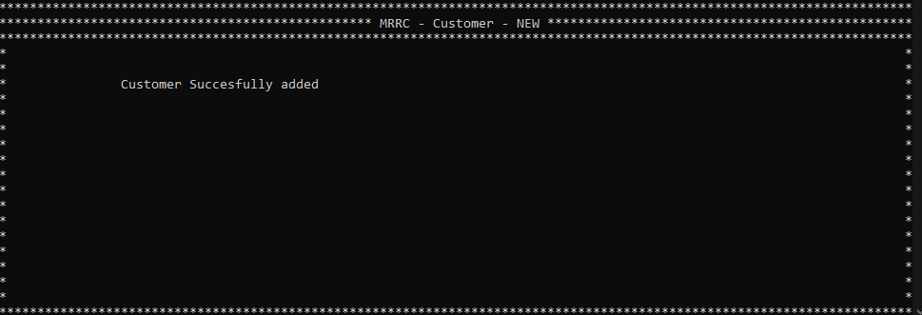

#### Modify and Search

When entering this screen will bring up a list of customers currently in the virtual database like the following:

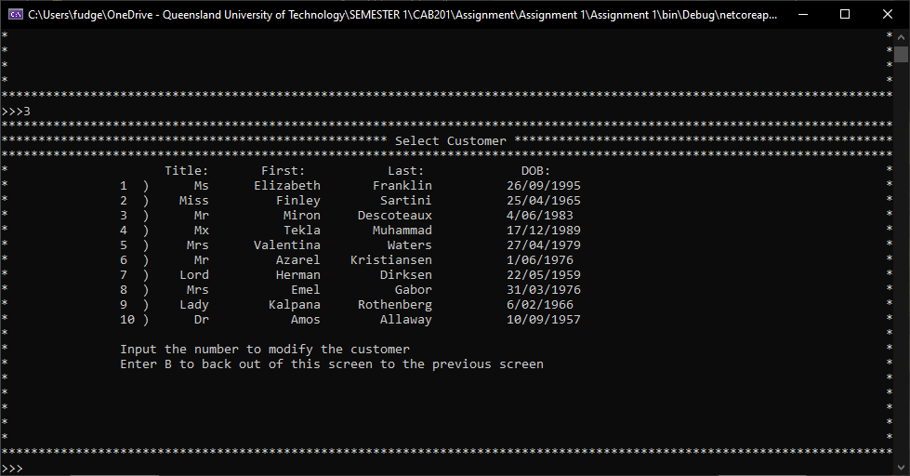

Enter the number and enter will bring up the modify screen for that customer

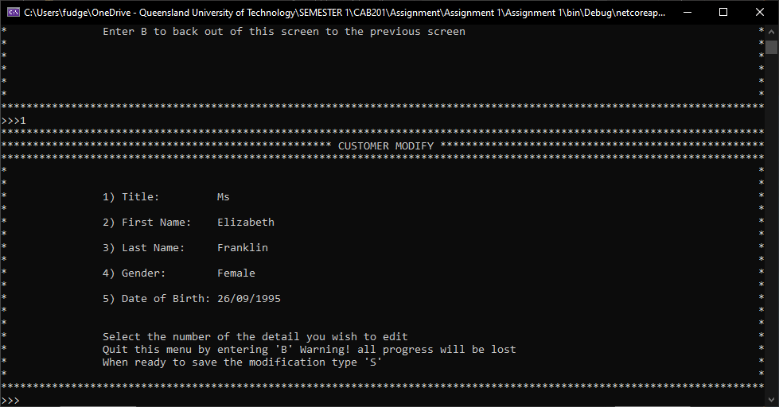

Enter the number to edit the field, if any input is incorrect an error describing what went wrong will appear. Once you are happy with the changes type S or s to save the changes.

NOTE: If there are multiple pages (a counter will appear in the top right of the screen) of customers simply type N or n to proceed to the next page or P to return to the previous page.

#### Delete Screen

This will initially load a screen like the Search and modify screen once a customer has been selected (much like 1 B). When a customer is selected the details will appear like the following:

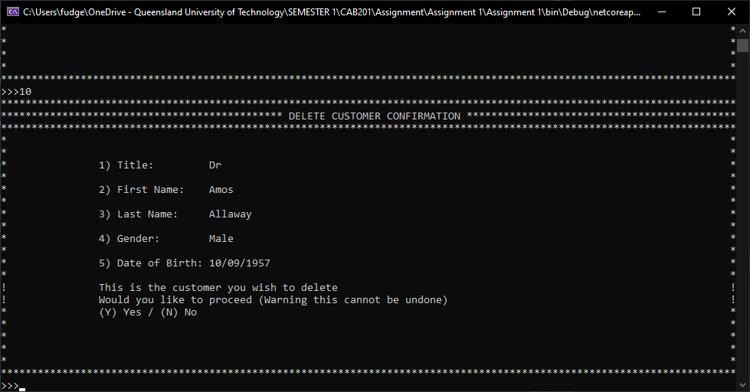

Asking for a final confirmation. If the customer is currently renting an error will appear.

### Vehicle Management

When entering the main screen for Vehicle Management the following screen will appear:

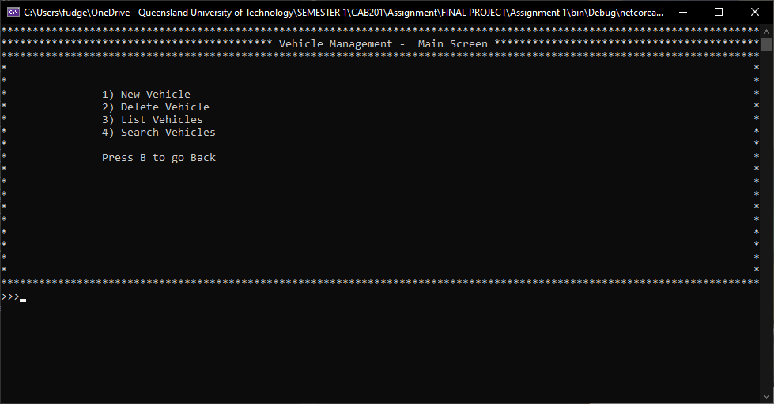

#### New Vehicle

Entering this part of the program will produce the following screen:

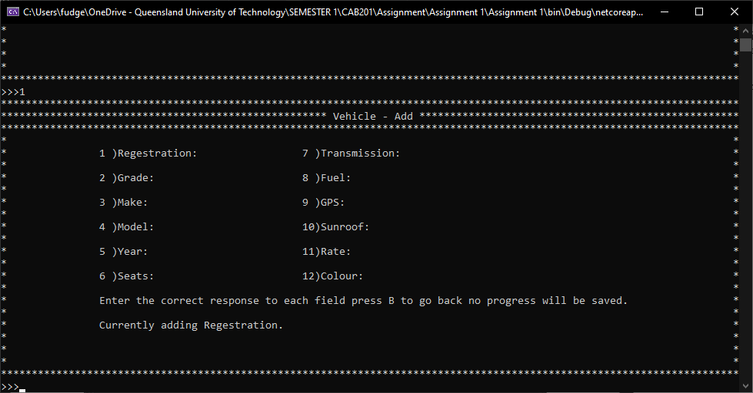

This works like the *New Customer* Page (see 1 C) simply type the values for each field at it will fill in as each input is successful. Producing an error with each if something is wrong.

NOTE: Certain information like Grade, Fuel, GPS and Sunroof will have limited responses this will appear on the screen.

Once the year has been inputted the form will be filled in with compony defaults relating to the grade. if this is incorrect type N when prompted to enter the modify screen. If there are no issues type S and a screen displaying if it was successful will appear.

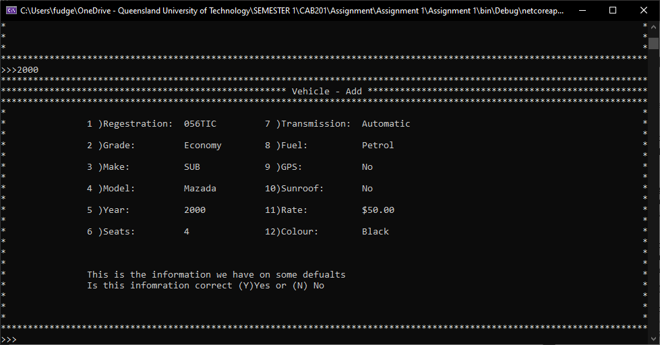

#### List Vehicle/Modify Vehicle

This works like List/Modify Customer (see 1 D). When entering this you will see the list of vehicles. Enter the number of which one you would like to edit, If multiple pages are required the page number will appear in the bottom left and use N and P to go to the next or previous page.

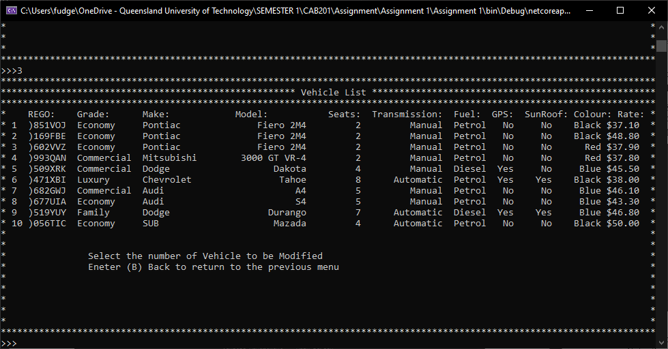

Once a vehicle has been selected the information will appear as follows:

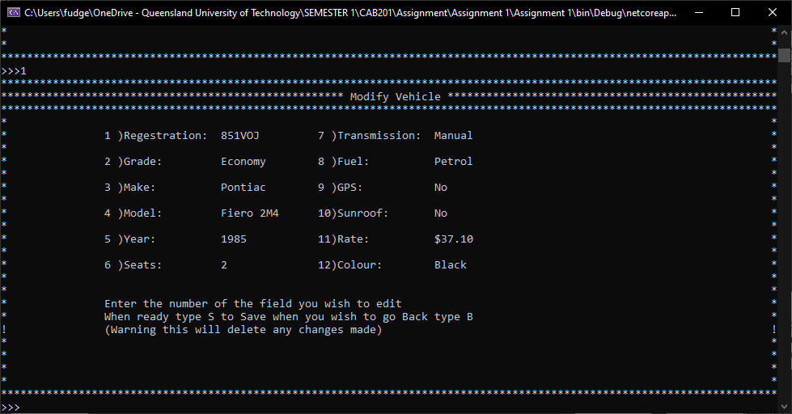

Edit the appropriate field using the numbers beside the field you wish to modify, if an input is incorrect you will be required to reinput. Once you are done with changing the vehicle information enter S when ready to save the new information.

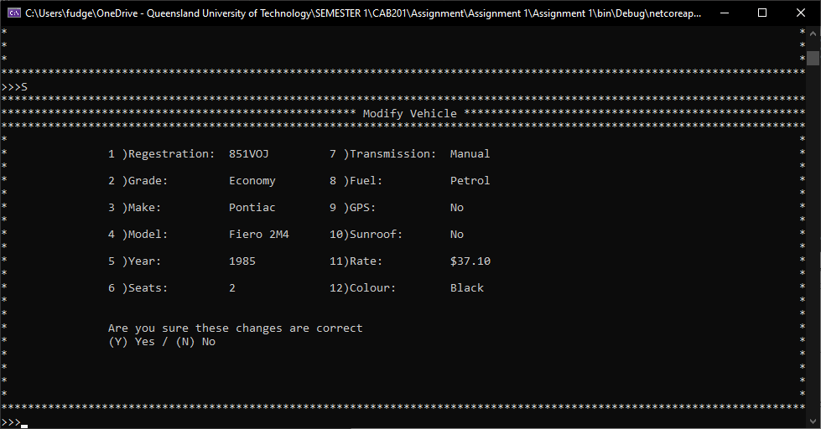

NOTE: Certain information like Grade, Fuel, GPS and Sunroof will have limited responses this will appear on the screen.

#### Delete Vehicle

Like previously mentioned this will bring up a list of the current vehicles within the database simply enter the number of the vehicle you wish to delete.

This will bring up the vehicle and information and asks for a final confirmation before deleting information simply type Y/N to confirm or deny choice. If it is being rented an error will appear on the screen.

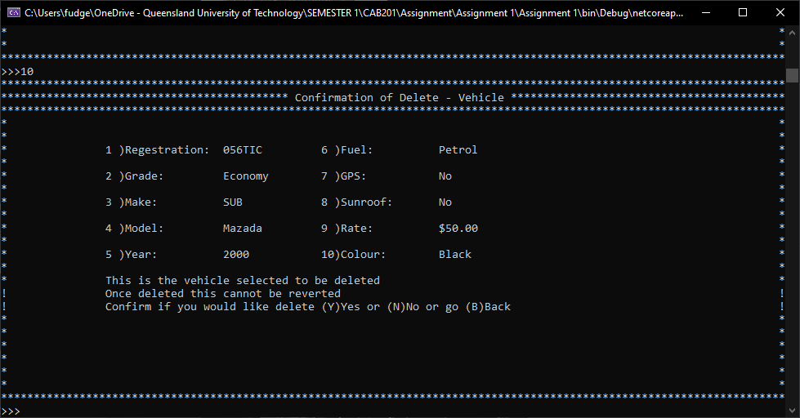

#### Search Vehicle

When entering this screen, the following appears:

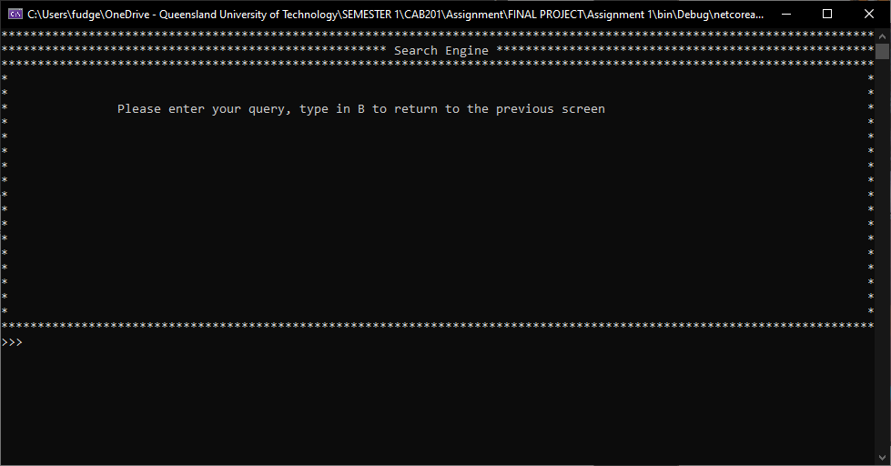

Be using a series of key words and a combination of brackets and OR and ANDs to retrieve a list of vehicles meeting the criteria.

NOTE:

* There is no way to search no GPS or no SunRoof
* When searching for the number of seats enter the number and then “-seater” i.e. “5-seater”
* The query needs to be written as *value OR/AND value* spaces before and after the operation

The resultant list will appear:

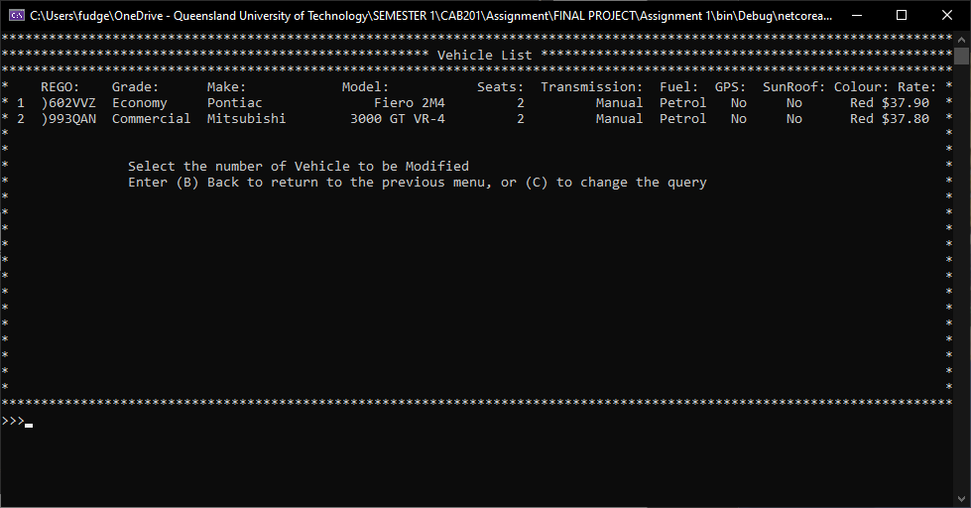

By entering the number this leads to the modify screen of the selected vehicle. Entering ‘C’ will allow the user to change the query.

### Rental Management

This screen produces the following menu:

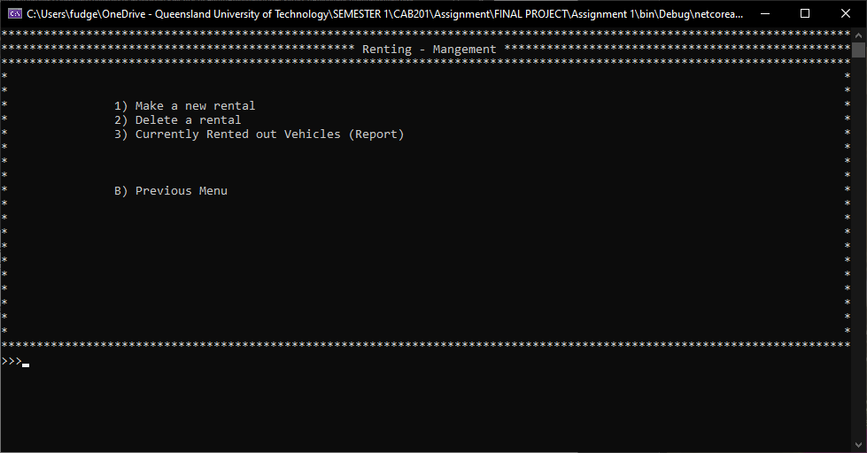

#### Make a new Rental

Entering this screen will produce the following:

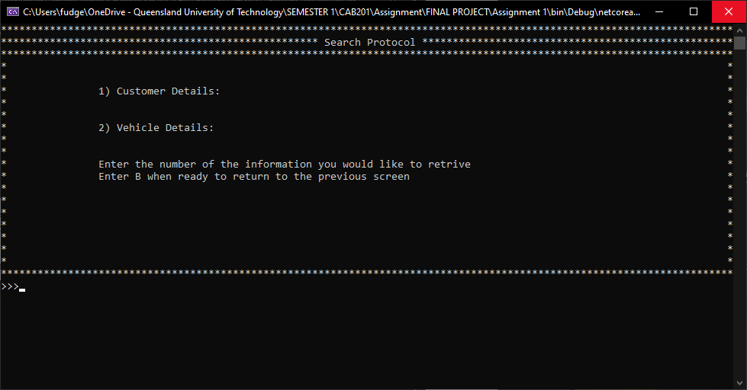

Enter the number will allow the user to retrieve the respective piece of information, entering the customer first will produce a screen like the customer modify screen, simple type the number to begin the renting process:

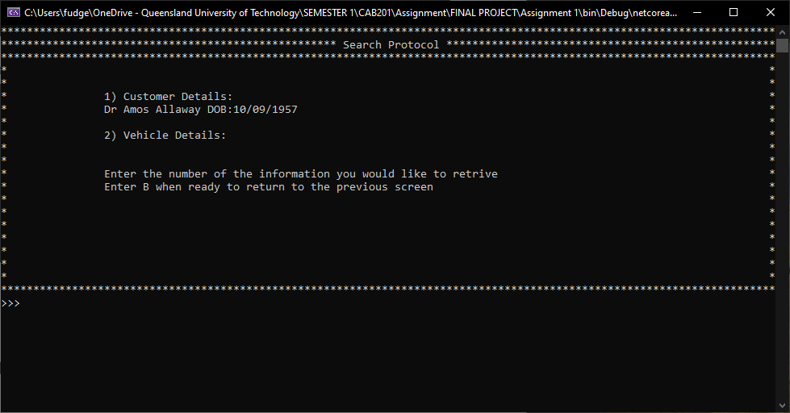

If the customer is renting, there will be an error produced. If the user selects the vehicle subsection, the search method choice will appear allowing the user to chose

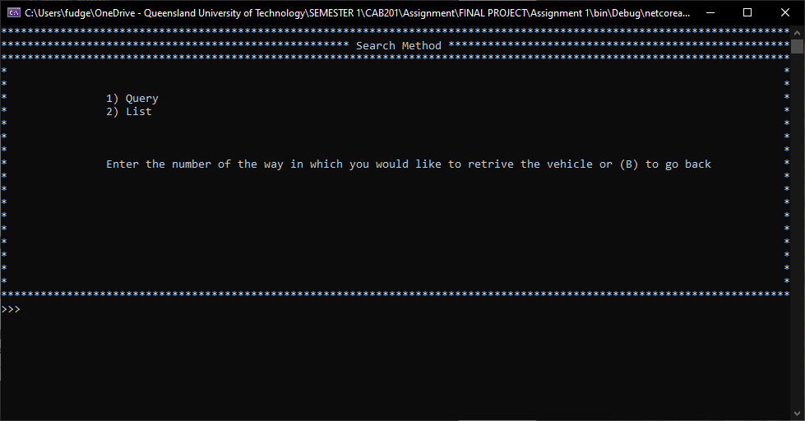

The user will be taken to the appropriate screen. Simple select the vehicle that is to be rented out after this a final confirmation screen will appear.



Type Y or N to confirm the details of the renting.

#### Delete a rental

This will produce the following screen:

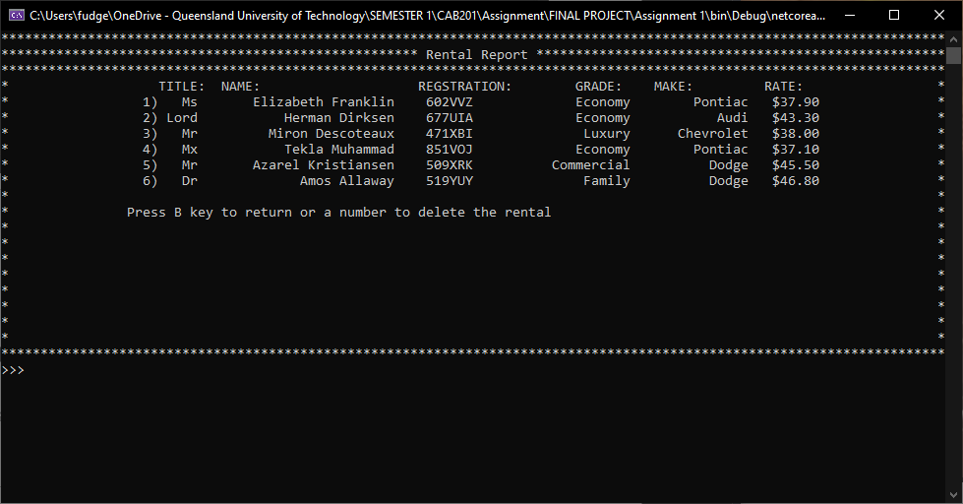

Enter the number of the record that the user would like to delete when this is done it will bring up a confirmation page:

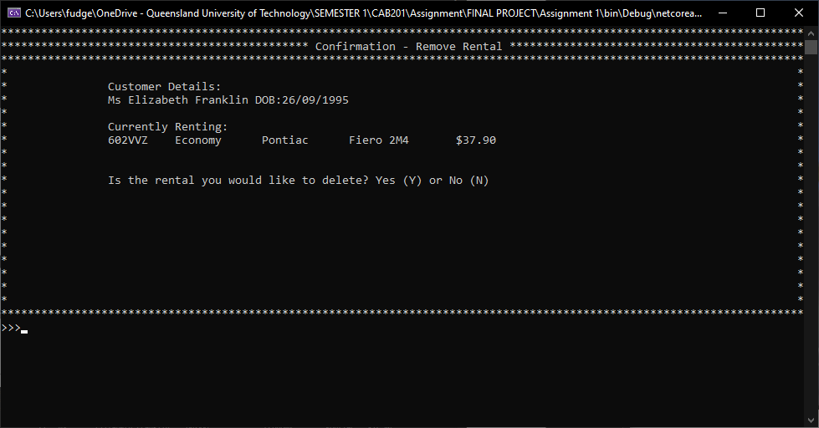

Typing Y or N will precede the program.

#### Currently Rented out Vehicles (Report)

This will produce a list of the currently rented out vehicles to which customer, simple hit enter when ready to exit this screen.

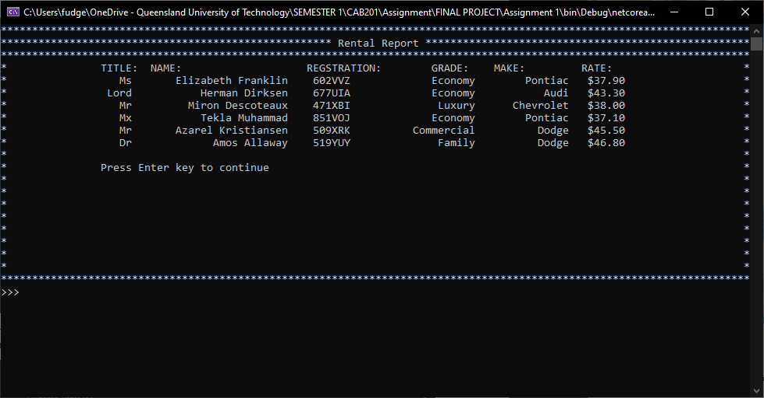

### Save/Load Database

Opening this screen will produce the following:

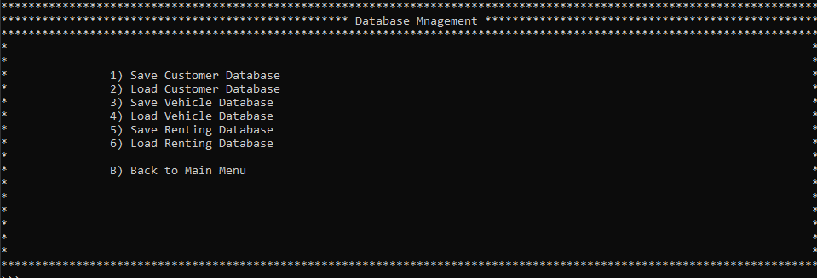

#### Saving

When Saving A database, the following screen displays, select which field to edit by typing in the number:

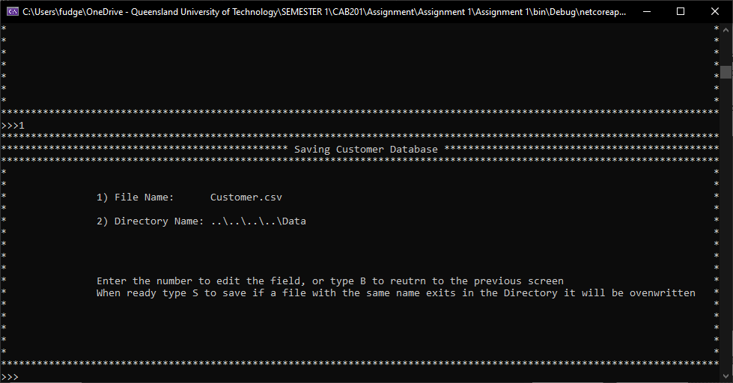

Changing the File name changes the name in which the database is stored, you can only use single word names (WARNING! If you save with the same name of another file the old file will be deleted please double check your file name before confirming).

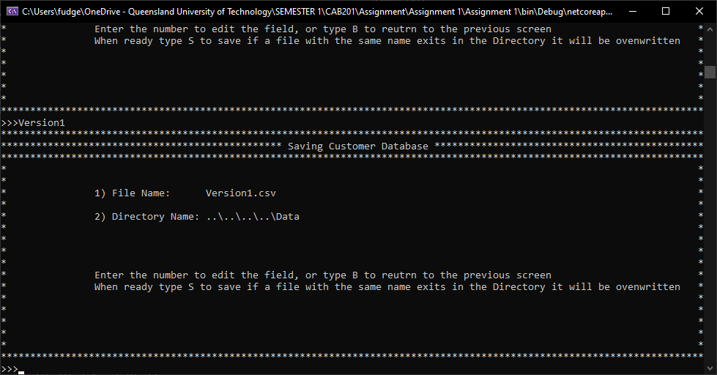

With changing the directory, you will need to open the desired location in your file explorer. Once the desired location has been found copy that into the field editor for 2 like so:

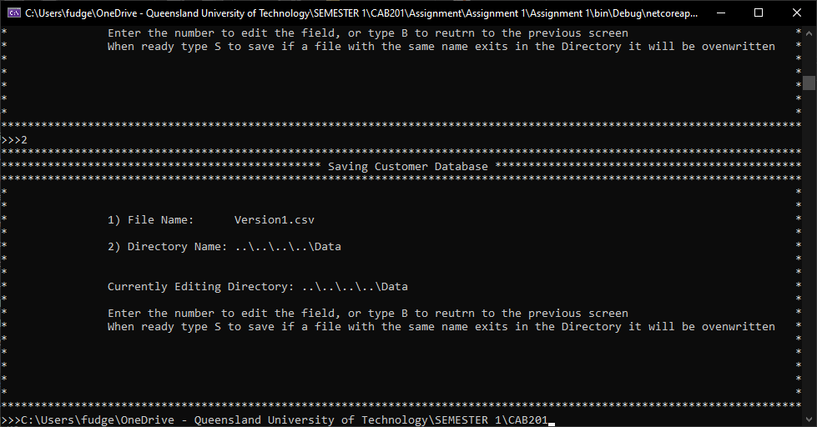

When ready with the options desired type S. And when successful a success screen will appear.

#### Loading

When entering a database to load you will be directed to input the directory in which your database is stored like so:

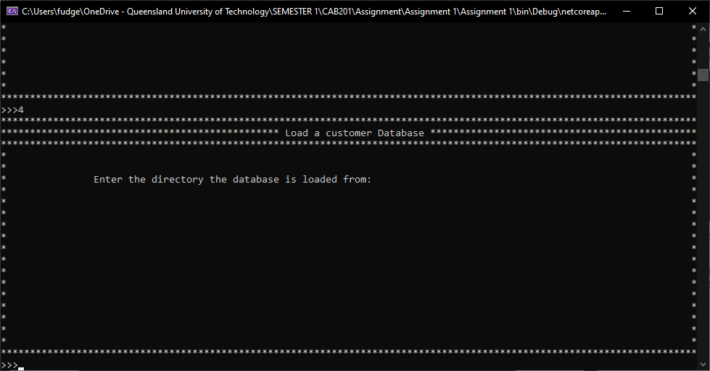

Entering the directory will produce the following screen, listing all the valid files in that directory that you can load information from enter the number of the database you wish to load:

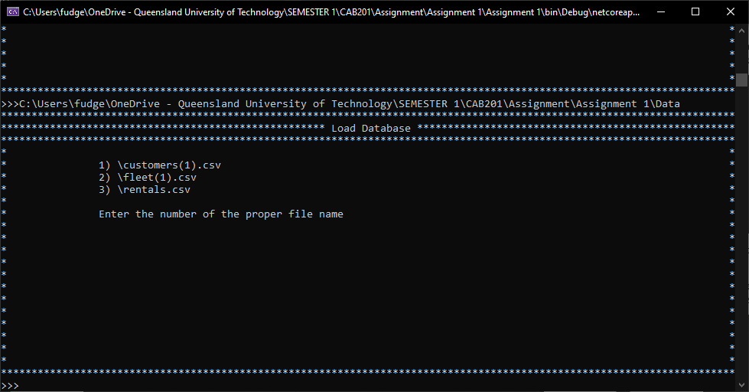

Warning this will delete any information that has been edited at this point make sure to save before Loading a new database.